STEAM Power

Let’s investigate STEM - Science, Technology, Engineering and Maths! Look around the museum. How many of these can you find?

A Scientist or inventor A Clock
An engine or machine A Computer
A tool A type of transport
Something you speak into Something you look into
Some used to measure things with
Something that is environmentally ‘Green’ - (low carbon) technology

Find a favourite STEM object.
What is it and how does it work?
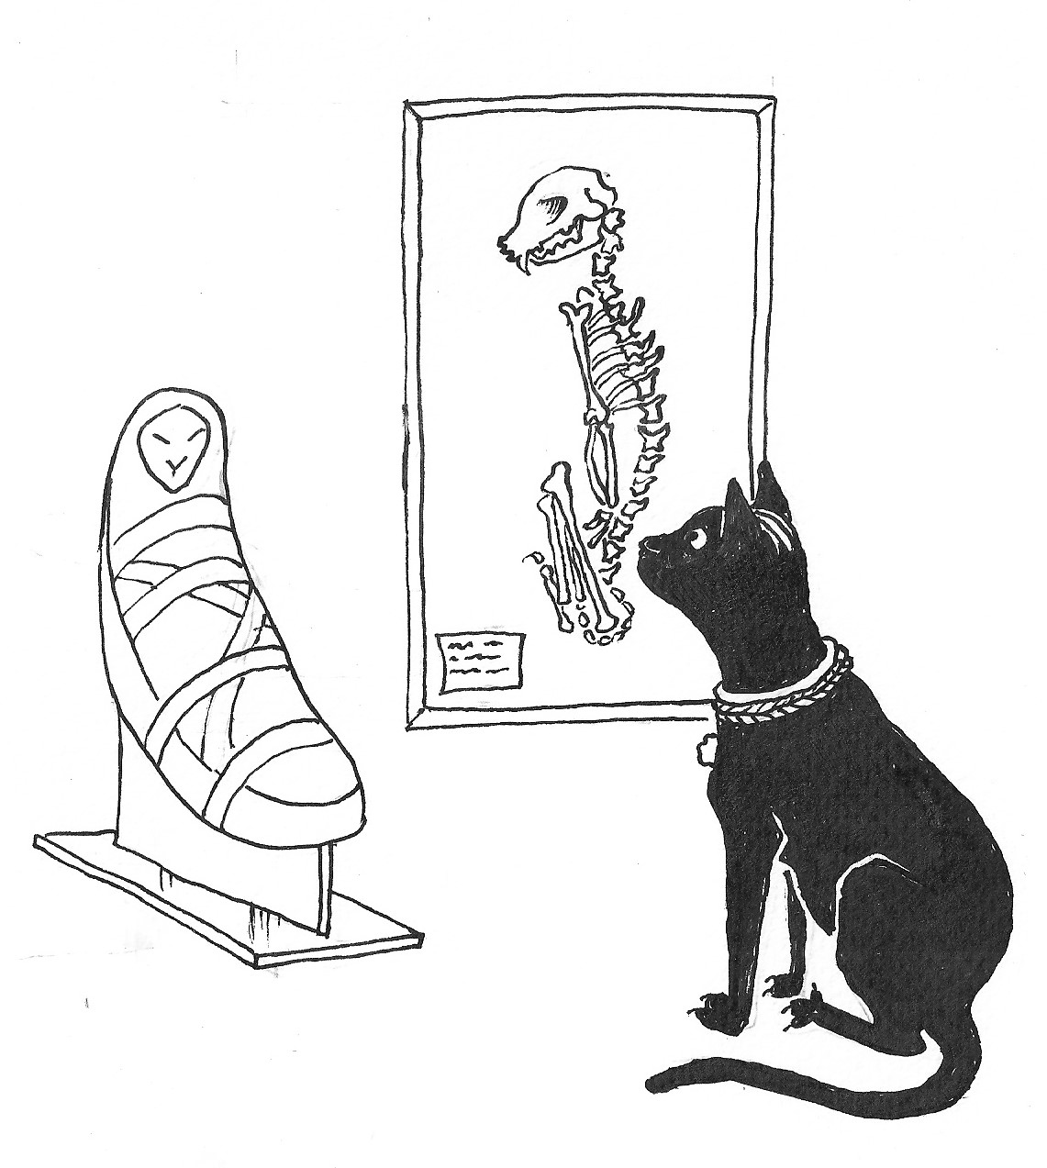

Mew really loves her science
She’s one of its greatest fans…
the secrets of cat mummies
revealed by X-rays and CAT scans.

