Oldest, Smallest, Bumpiest, Tallest!
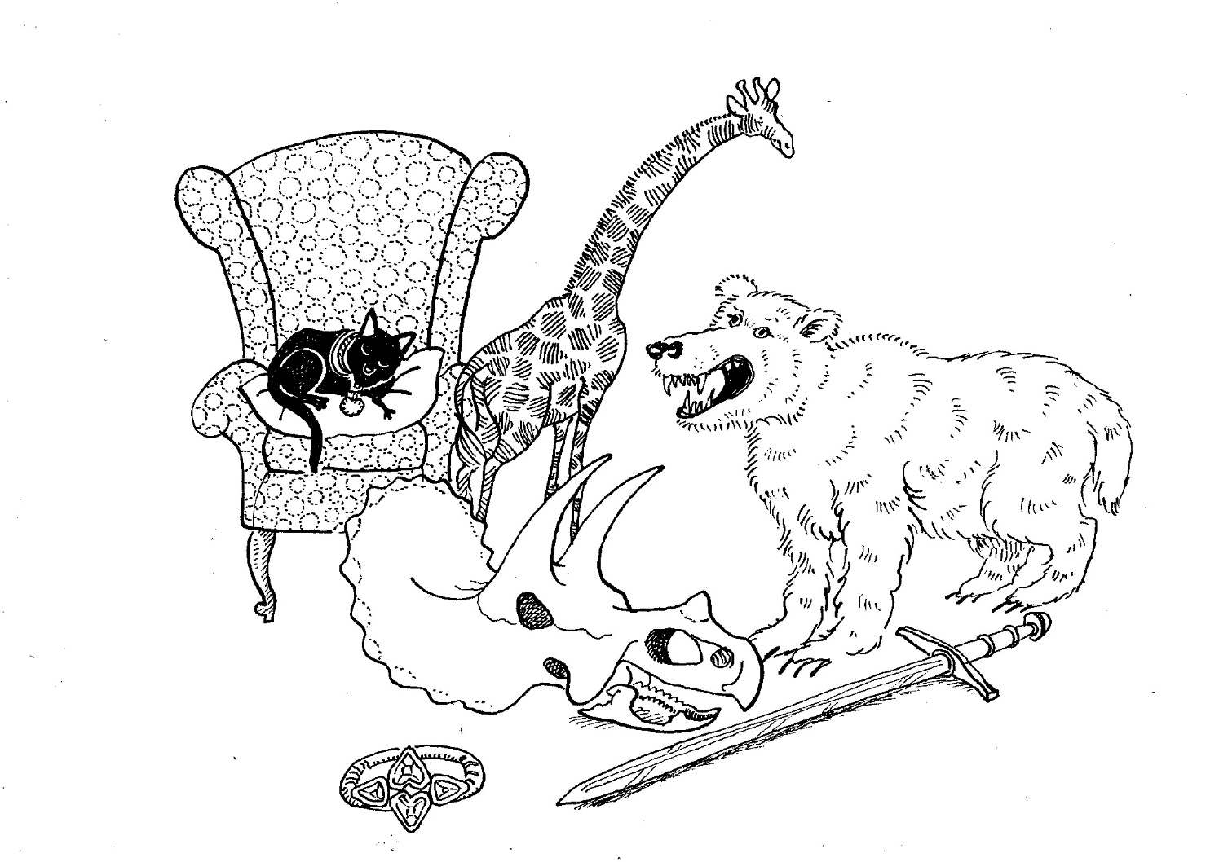

There are lots of things in the museum, can you find which are the…

Oldest, smallest, bumpiest, tallest?
Hardest, softest, brightest, dullest?
Strangest, cutest, scariest?
Spots, Stripes, Squares or plain?

