Animal safari

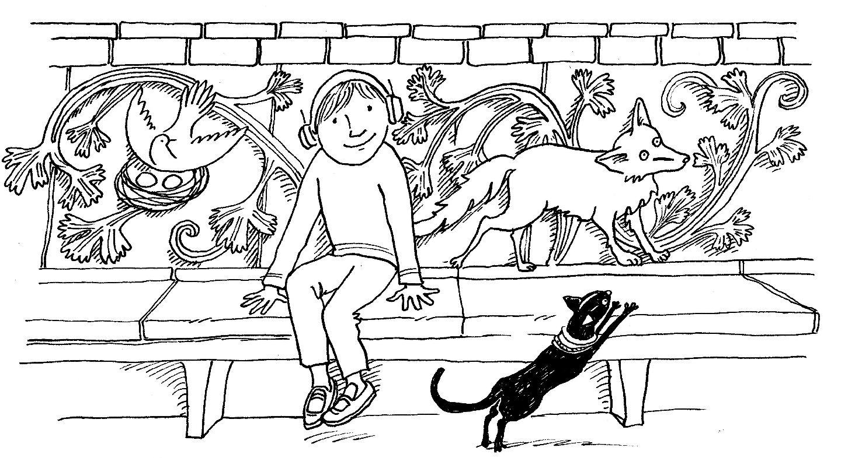

Find 5 animals. They might be stuffed, in pictures or as decoration on objects.
Which is the largest, smallest, funniest, scariest?
Pretend to be one of the animals and make its sound.

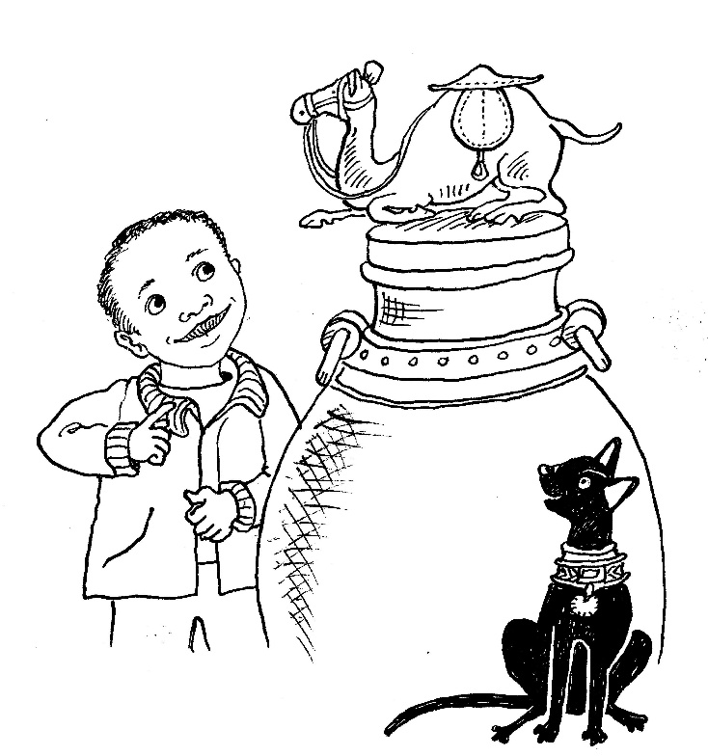
Mew loves to hunt for animals
She counts them in their dozens.
And only gets a little scared
if she meets her big cat cousins!

