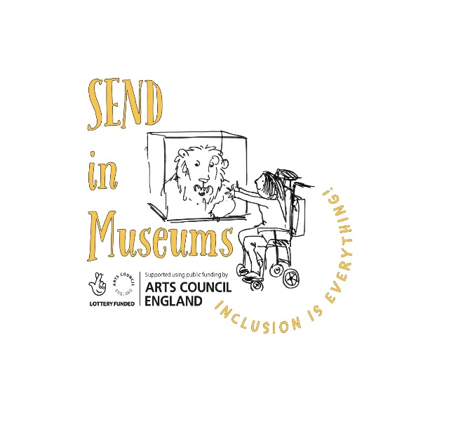
Case study submission form

Thank you for your contribution to www.sendinmuseums.org
Case studies from museums help to showcase what is possible and encourage others to try something new. Please complete this word document and email it along with a high-resolution image (with permission to use on the website) to: info@sendinmuseums.org

Name of Museum: Hull Museums

Date of work: Ongoing (from summer 2021)

Title/theme of work: Medieval Gallery

Details of case study including: aims, outcomes, who reached and resources needed, cost, time taken:

I took over project managing the re-interpretation of the Medieval Gallery during the pandemic, and through that lens, accessibility took on an even greater significance. There were understandably lots of delays to the project because of the restrictions we were all living with; companies had staff on furlough, people were working from home, suppliers had difficulty getting all the products they needed and for a few months we were all working from a memory of what the gallery looked like.
The main aim was to refresh the gallery, a part of the museum which was sometimes bypassed by visitors and allow it to be embraced by our largest audience, families. A major aspect we wanted to address was the lighting, which had caused so much difficulty to so many visitors; whether it was just a bit spooky for younger visitors, or if visitors needed to lip-read or were finding it difficult to see the objects in the cases. We also wanted to make the text accessible; could we appeal to our large family audience and adults interested in the medieval period at the same time?
In addition to getting the basics right, we want to try something new and really embrace accessible technology. We are working with IPass, Hull City Council’s physical and sensory support service for schools to create large print versions of all the text, and install them in a disability friendly way and to record British Sign Language interpretation videos for all the panels.
From start to finish the project has taken nearly 3 years due to the pandemic but the accessibility additions are still ongoing, to make sure we get it right and they are implementing properly. The budget for the whole project was £30,000.
One of the best outcomes is that the project has served as testing ground for improving accessibility and can serve as a benchmark for projects and exhibitions going forward.

Top tips or additional comments following the work:

