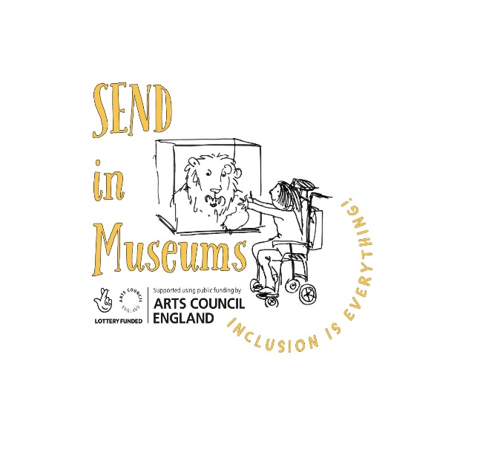
Case study submission form

Thank you for your contribution to www.sendinmuseums.org
Case studies from museums help to showcase what is possible and encourage others to try something new. Please complete this word document and email it along with a high-resolution image (with permission to use on the website) to: info@sendinmuseums.org

Name of Museum: Museum of English Rural Life, University of Reading

Date of work: 2020 - 2022

Title/theme of work: Everybody Outdoors: Inclusive Approaches for Outdoor Learning for Complex Needs/ PMLD Teachers

Details of case study including: aims, outcomes, who reached and resources needed, cost, time taken:

This resource comprises films and accompanying PDFs for PMLD and Complex Needs teachers, providing ideas and approaches for outdoor learning experiences which can be used in teaching. The resources start with a Sensory ‘Seasons’ Story housed on the Museum’s You Tube channel which can be watched in the classroom. It is then followed by different resources which follow the journeys of some of the characters in the story. These resources (in the forms of films and downloadable PDFs) give tips and ideas for developing opportunities for enabling students in nature. These resources were co-designed with our partner, Addington School in Wokingham. As well as being resources which can be downloaded and used in the classroom, we also have resource boxes in the museum which can be used as part of an onsite museum workshop.
Sensory opportunities covered in the resources:
- Reflection, light and touch
- Smell and texture
- Sound, air and texture
- Sound, smell and touch
- Self directed learning opportunities
Objectives:
- To equip PMLD and Complex Needs teachers with ideas which are responsive and adaptable. Using the resource, students will have opportunities to:
    - Engage in a range of multi-sensory experiences to explore the outdoors and the environment
    - Have opportunities to make choices
    - Engage in opportunities which promote the love and wonder of nature
    - Experience activities whatever the weather, with options to bring the outside in with indoor and outdoor engagement opportunities

Who reached:
The resources were developed with:
- Complex needs/ PMLD students at Addington School and staff (14 students and 14 staff)
- Gifted and Talented students at Addington School who made puppets and acted as puppeteers for our Sensory Seasons Story

Cost:
- £1000 professional fees
- £200 materials
- £2500 film making costs

Top tips or additional comments following the work:
- Consultation with complex needs teachers was key in creating the resources. That stressed the need for the resources:
    - to be sensory
    - to give options for inside and outside engagement
    - to provide options, opportunities for staff to observe student preferences and enable students to make choices
    - to be adaptable to different needs and provide person centred opportunities
- The original intention of this work was to develop a learning offer for complex needs students onsite at the museum and in the museum garden. The pandemic meant a rethinking of our approach to instead create resources which could be used in different outdoor settings as well as ultimately being available as a workshop at The MERL too.

